**CHAPTER I**

**Introduction**

In the continuing era of progress of mankind, people endlessly seek breakthroughs; breakthroughs that can be utilized to make our way of living a lot easier and more comfortable. As human, being comfortable in our workplace, school, office, malls and especially in our homes is very important for it helps us to relax, focus on the activity we are doing and maintain ones health. One way of achieving this state of comfort in any room space is through the use of air conditioning.

Batangas City, the capital of Batangas Province is a coastal city lying in a cove-like shape at the south-eastern portion of Batangas Province. Being the capital city, many industrial, commercial and educational institutions are built here. However, the high temperature rise during dry season in the city is a major problem for these buildings. The geographical location of the city is one of the factors that cause this climatic condition. It should be dealt with because this condition may cause uneasiness and unhealthy state for the occupants within the buildings. This information leads the proponents to design and establish an effective air conditioning system in one of the universities located in Batangas City.

Air conditioning is defined as the process of treating air so as to control simultaneously its temperature, humidity, cleanliness and distribution to meet the condition of a given space. Conditioning of air can be adding or removing heat from the air to be distributed to the conditioned space. For the university to be designed with air conditioning system the mode of cooling will be applied.

**Objectives of the Design**

The main objective of the design plate is to provide a design of air conditioning system for a four-storey building located at Batangas City.

Specifically, it aims to:

1. Evaluate the physical aspects of the building components as well as the materials of construction of the building and all the factors that contribute to the cooling space;
2. Estimate/calculate the building cooling loads using the different procedures laid in ASHRAE Data Guide Book with the selected outdoor and indoor design conditions at the peak hour of the day.
3. Choose an AC unit in the available catalogue based on the computed cooling load and design for appropriate dimensions of duct if necessary.

**Importance of the Design**

The designed Air Condition System would mostly be beneficial to the occupant of the building in University of Batangas, Philippines.

The output of the designed Air Condition System would help the proponents and other engineering students to gain and develop knowledge by applying different principles and theories that they would encounter through the course of the study. They will also be able to practice what they have learned from their instructors and manuals in designing air conditioning unit that would suit best to any building for example is the four-storey building of University of Batangas. They will be able to experience actual practice where they will study and analyze the factors considered in designing an AC system like the location of the building, total area to be conditioned, occupant of conditioned space and even the climatic condition of the locality. Also, it will help the researchers to build their individual skills and confidence that will make them more competent in the real industrial world

**Definition of Terms**

**Air Conditioning –** as defined by the American Society of Heating, Refrigerating and Air Conditioning Engineers (ASHRAE), it is the process of treating air so as to control simultaneously its temperature, humidity, cleanliness and distribution to meet the requirements of the conditioned space.

**Air** – an invisible, odorless, and tasteless mixture of gases, which surround the earth; it has weight, temperature, specific heat and conductivity.

**Climate** – the weather conditions of a region; conditions include temperature, humidity, sunshine, pressure and air movement.

**Dew point.** In this study, this refers to the temperature below which water vapor in the air will start to condense.

**Diffuser.** In this study, it delivers widespread fan shaped flows of air into the room; it provides air patterns in which the velocity decays before the air reaches occupied regions of the room.

**Dry Air** – a non-condensing component of the mixture, mainly the nitrogen and the oxygen.

**Dry Bulb Temperature** – the air temperature taken with the sensitive element of the thermometer in a dry condition.

**Humidity** – term used to describe the presence of moisture of water vapor in the air.

**Humidity Control.** In this study, it is used to keep the relative humidity of air-conditioned rooms at satisfactorily level.

**Latent Heat** – the heat added to or removed from a substance to cause a change of state.

**Moist Air.** In this study, this refers to a binary or two-component mixture of dry air and water vapor.

**Psychrometric Chart** – a graph of the properties of air; used to determine how these properties vary as the amount of moisture in the air changes.

**Psychrometry** – the science and practice of dealing with air mixture and their control; it deals mainly with dry air and water vapor mixtures.

**Relative Humidity** – term used to express the amount of moisture in a given sample of air in comparison with the amount of moisture the air would hold if totally saturated at the temperature of the sample; it is stated in a percentage.

**Saturated Air.** In this study, this refers to the vapor in air, which is saturated.

**Sensible Heat** – the heat added to or removed from a substance that can be measured by a change in temperature.

**Specific Heat of Air** – the amount of heat required to raise the temperature of one pound of air one degree Fahrenheit or one kilogram of air one degree Celsius. The specific heat of air at sea level is. 1.0062 KJ/Kg-K

**Sensible Heat Ratio** – a scale given on the right side of a psychrometric chart; the ratio of sensible heat to the total added when moving from one point to another on the psychrometric chart.

**Vapor.** In this study, this refers to the condensing component of the mixture, the water vapor or stream, which may exist in a saturated or superheated state.

**Ventilation** – term applied to change the air in a workplace or living place.

**Wet Bulb Temperature** – the air temperature taken when evaporation of moisture is experienced.

**Background of the Study**

The City of Batangas is a coastal city lying in a cove-like shape at the south-eastern portion of Batangas Province. It is bounded on the northwest by the municipality of San Pascual; on the north by the municipality of San Jose; on the east by the municipalities of Ibaan, Taysan and Lobo; and on the south by the Batangas Bay.

Batangas City, the capital of Batangas Province has a total land area of more or less 28,541.44 hectares. It is about 112.00 kilometers away from Manila. It has a rolling terrain that ranges from 0% to 30% in slope. Its highest point is Mount Banoy in Barangay Talumpok Silangan which is 968 meters above sea level and about 13.50 kilometers east of the Poblacion.

Batangas City is generally coolest during the months of December to January with temperature ranging from 22ºC to 26ºC. The mean temperature rises and attains a maximum of 36 degrees Celsius (36ºC) in May. The month of October marks the steady fall of temperature.

The driest months in Batangas City are from January to April, with the average monthly rainfall of less than 50 mm per month. The northeast monsoon “amihan” prevails starting the months of November up to April. Although originally moist, it becomes comparatively drier after crossing the Sierra Madre Range to the north and east of Batangas, thus attributing for predominantly dry weather during this period. By May to the later part of October, the situation is reversed. The southwest monsoon “habagat” prevails bringing with it considerable rain. A pronounced maximum rain period occurs in Batangas during the months of June, July, August and September when southwest monsoon flow is steadiest and the average monthly rainfall is 275 mm per month. By the end of October, the northeast monsoon starts to set again. However, the months from October to December are not characterized by dry weather as compared to the months from January to April. This is partly due to the fact that typhoons and depressions most frequently affect the city during the months from July to December.

**Project Location and Design Building Orientation**

**A. Climatic Condition of the Locality**

The climatic condition of a four-storey school building at Western Philippine Colleges compound, Hilltop, Batangas City is as follows with respect to 16 degrees North latitude on the earth surface, while the longitude was approximately 32 degrees East longitude on the earth surface. The building height measures 3.5 meters for second to fourth floor and also in the penthouse. Commercial Space for ground floor height is 6 meters. The summer condition is estimated to have 35 degree Celsius on dry bulb and 27 degree Celsius on wet bulb based on psychrometric chart of outside temperature. The percent relative humidity is about 50% RH. Daily range in the locality takes 15 degree Celsius. Solar haze factor is zero.

**B. Building Orientation**

The four-storey school building that the researchers chose is located at Western Philippine Colleges Compound, Hilltop, Batangas City. The front of the building faces North. The layout of the building is shown in the appendix.

**CHAPTER II**

**DESIGN PROPER**

This chapter presents the essential data required in establishing the appropriate air conditioning system to be used in the design proper. This includes the building components, material construction and the heat load calculation.

Each of the ground floor, second floor, third floor, fourth floor, and fifth floor consists of sixteen rooms with two toilets for each room, elec/mech room, and dishwashing area. Aside from roof deck, the roof top consists of elec/mech room, recreation room, laundry room, pump room, store room, and two janitor rooms.

**Building Components and Materials Construction**

Building boundaries of the building structure consists of a wall section, roof section, glass portion and internal partitions exposed to external condition.

**External Resistances and U-value**

1. External Wall Section

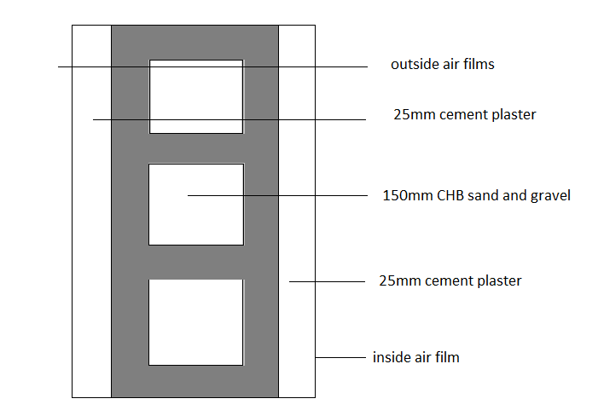

|  |  |  |
| --- | --- | --- |
|  | R, m2 ⁰K/Watt | ρS, Kg/m2 |
| outside air film | 0.0290 | --- |
| 25 mm cement plaster | 0.0347 | 1598 |
| 150mm CHB sand and gravel | 0.1350 | 980 |
| 25mm cement plaster | 0.0347 | 1598 |
| inside air films | 0.12 | --- |
|  | RT = 0.3534m2K/W | ρST = 226.9 Kg/m2 |
|  | **UW = 2.829654782 W/m2K** | **TYPE F** |

2. Roof Section

2.1 External Roof

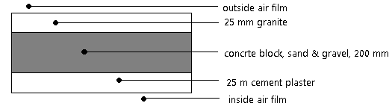

|  |  |  |
| --- | --- | --- |
|  | R, m2K/W | ρS, Kg/m2 |
| outside air film | 0.044 | --- |
| 25 mm granite | 0.01375 | 42.5 |
| 200 mm concrete block, sand &gravel | 0.18 | 196 |
| 25 mm cement plaster | 0.02919 | 39.95 |
| inside air film | 0.12 | --- |
|  | RT = 0.38694 m2K/W | ρST = 278.45 Kg/m2 |
|  | **UW = 2.584380007 W/m2K** | **TYPE 6** roof without suspended ceiling |

2.2 Roof of the penthouse at the roof top

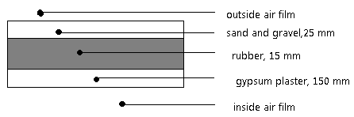

|  |  |  |
| --- | --- | --- |
|  | R, m2K/W | ρS, Kg/m2 |
| outside air film | 0.044 | --- |
| Sand and gravel | 0.01375 | 55 |
| Rubber | 0.41344 | 13.65 |
| Concrete | 0.135 | 147 |
| Gypsum Plaster | 0.04125 | 10 |
| inside air film | 0.016 | --- |
|  | RT = 0.6634375 m2K/W | ρST = 225.65 Kg/m2 |
|  | **UW = 1.507300989 W/m2K** | **TYPE 5** roof with suspended ceiling |

3. Glass Portion

3.1 Glass Window

1.5m x 0.625m, single glass, 4-panel, regular sheet( 2nd floor)

From Table 1.0 Resistance of Building Materials, use U=5.9 W/m2K

3.2 Glass Door

1m x 2.2m, single glass, double-pane, regular sheet

From Table 1.0 Resistance of Building Materials, use U=5.9 W/m2K for single glass during summer condition.

4. Considered Internal Partition

4.1 Partition Wall



|  |  |  |
| --- | --- | --- |
|  | R, m2 ⁰K/Watt | ρS, Kg/m2 |
| outside air film | 0.0290 | --- |
| 25 mm cement plaster | 0.0347 | 1598 |
| 150mm CHB sand and gravel | 0.1350 | 980 |
| 25mm cement plaster | 0.0347 | 1598 |
| inside air films | 0.12 | --- |
|  | RT = 0.3534m2K/W | ρST = 226.9 Kg/m2 |
|  | **UW = 2.829654782 W/m2K** | **TYPE F** |

4.6 Partition Door

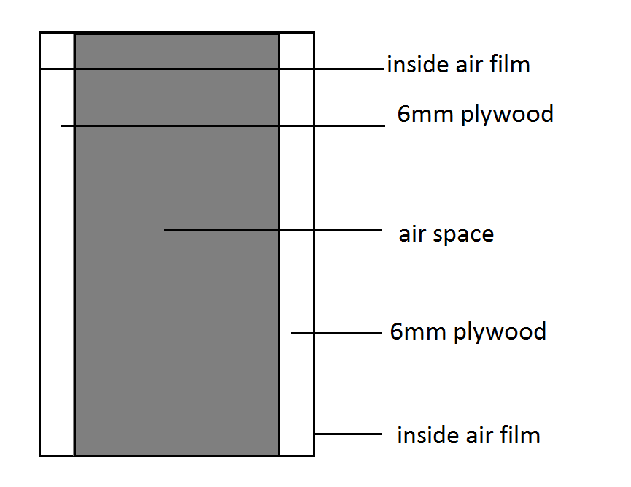

|  |  |  |
| --- | --- | --- |
|  | R, m2K/W | ρS, Kg/m2 |
| inside air film | 0.12 | --- |
| 6 mm plywood | 0.05196 | 580 |
| air space | 0.17 | --- |
| 6 mm plywood | 0.05196 | 580 |
| inside air film | 0.12 | --- |
|  | RT = 0.51392 m2K/W | ρST = 6.96 Kg/m2 |
|  | **UW = 1.945828144 W/m2K** | |

**Calculation information**

This calculation information contains the computation of different heat load which comprises the external heat load and internal heat load calculation. Specific formulas for a particular heat load were used based on the parameters necessary to obtain the required heat load.

**EXTERNAL HEAT LOAD CALCULATION FORMULAS**

1. **EXTERNAL WALL HEAT LOAD**

*QW =UWAWCLTDadj*

where,

*CLTDadj = (CLTDmax + LM)k + (25-ti) + (29-ti)*

UW = heat transfer coefficient

AW = area of the wall

CLTDadj = cooling load calculation

1. **EXTERNAL ROOF HEAT LOAD**

*QR = URARCLTDadj*

where**,**

*CLTDadj = f[ (CLTDsel + LM)k + (25-ti) + (29-ti)]*

CLTDsel = selected cooling temperature difference

LM = correction for latitude and month of the year

*tave = to – ½ (daily range)*

= 45 – ½ (14)

**tave = 38 oC**

k = permanently light colored (0.65)

1. **EXTERNAL DOOR HEAT LOAD**

*QR = UDAD(*∆t)

where**,**

∆t = to – ti

1. **EXTERNAL GLASS WINDOW HEAT LOAD**

*QG = QSG + QTH*

*QSG = (SHGF)(SC)(A)(CLF)*

*QTH = UG(AG)(ΔT)*

where,

SHGF = Maximum solar heat gain factor

SC = shading coefficient

AG = area of glass

CLF = cooling load factor

**INFILTRATION AND VENTILATION FORMULAS**

1. **INFILTRATION HEAT LOAD**

Sensible Heat Gain: *QS =1.232QΔT*

Latent Heat Gain: *QL = 3000QΔW*

where,

Q = infiltration rate

*Q =(no.f air changes/ hr)(volume of the conditioned space)*

*No. of air changes = a + bV + c(to-ti)*

ΔT = outside and inside air temperature difference

ΔW = outside and inside air humidity ratio difference

1. **VENTILATION HEAT LOAD**

Sensible Heat Gain: *QS =1.232QΔT*

Latent Heat Gain: *QL = 3000QΔW*

where,

Q = ventilation rate

*Q = (outdoor air requirements per person)(no. of person)*

ΔT = outside and inside air temperature difference

ΔW = outside and inside air humidity ratio difference

**INTERNAL HEAT LOAD CALCULATION FORMULAS**

1. **OCCUPANT LOAD**

*Q = QS + QI*

where,

*QS = qs(N)CLF*

*Ql = ql(N)CLF*

N = number of occupants

qs = sensible heat gain per person

ql = latent heat gain per person

CLF = cooling load factor

**B. LIGHTING LOAD**

*Q = (lamp rating in Watts per m2) Area (Fu)(Fb)CLF*

where,

Fu = lamp utilization factor

Fb = ballast factor for fluorescent lamps

CLF = cooling load factor

1. **MISCELLANEOUS HEAT LOAD**

*Q = equipment electrical rating (Fu)CLF*

where,

Fu = utilization factor

CLF = cooling load factor

1. **PARTITION LOAD**

*QS = UAΔT*

where,

QS = partition sensible heat load

U = overall heat coefficient

A = area of the partition ΔT = temperature difference

|  |  |  |  |  |  |  |  |  |  |  |  |
| --- | --- | --- | --- | --- | --- | --- | --- | --- | --- | --- | --- |
| **University of Batangas - Room Data Sheet** | | | | |  |  | |  |  |  |  |
| **External Design Condition** | |  | | |  |  | |  |  |  |  |
| **Summer** | : 35 0CDB / 27 0CWB | | | |  |  | |  |  |  |  |
| **U-Values (W/m2-K)** | External | |  | | Internal/Partition |  | |  |  |  |  |
|  | Roof | | 1.507300989 | | Wall of CR | 2.829654782 | |  |  |  |  |
|  | Door | | 1.945828144 | | Door of CR | 1.945828144 | |  |  |  |  |
|  | Glass Door | | 5.9 | |  |  | |  |  |  |  |
|  | Glass Window | | 5.9 | |  |  | |  |  |  |  |
|  | SC of windows | | 0.55 | |  |  | |  |  |  |  |
|  | Wall | | 2.829654782 | |  |  | |  |  |  |  |
|  |  | |  | |  |  | |  |  |  |  |
| **Area Description** | **Space Temperature** | | **Cooling Internal Load** | | | | | | | **Outside Air** | |
| Internal Lighting  W/m² | Power  W/m² | | Occupancy | | | Infiltration rate | lps / person | |
| Watts/ person | (sensible W/ latent W) | | ACH |
| Ground floor  (**Commercial Space 1-12**) | 25ºC 50%RH | | Lights = 25 watts/m² | Misc. = 15 watts/m² | | 185 | 50/50 | | 0.2225 | 15 | |
| Second floor  ( **Office 1-8** ) | 25ºC 50%RH | | Lights = 24 watts/m ² | Misc. = 15 watts/m² | | 150 | 55/45 | | 0.2225 | 70 | |
| Third Floor  (**Classroom 1-5**)  (**Office 1**) | 25ºC 50%RH | | Lights = 20 watts/m² | Misc. = 15 watts/m² | | 2.5  10 | 60/40  55/45 | | 0.2225 | 4.7  2.5 | |
| Fourth Floor  (**Classroom 1-5**)  (**Office 1**) | 25ºC 50%RH | | Lights = watts/m² | Misc. = 15 watts/m² | | 2.5  10 | 60/40  55/45 | | 0.2225 | 4.7  2.5 | |
| Penthouse  ( **Bedroom 1-2**) | 25ºC 50%RH | | Lights = watts/m² | Misc. = 15 watts/m² | | 70 | 88.2/35 | | 0.2225 | 26.36625 | |

**EXTERNAL WALL HEAT LOAD CALCULATION**

|  |  |  |  |  |  |
| --- | --- | --- | --- | --- | --- |
| **EXTERNAL WALL HEAT LOAD (GROUND FLOOR)** | | | | | |
| Room | Orientation | U - value | Area,m2 | CLTDadj = (CLTD + LM) (k) + 25 - ti + tave - 29 | QS = U x A x CLTDadj |
| **Commercial Space**  **(1)** | E | 2.829654782 | (10.5m)(6m) = 63m2 | (25-0.55)(0.65)+(25-25)+(29.5-29) = 16.3925oC | (2.829654782)(63)(16.3925) = 2922.262309W |
| S | 2.829654782 | (4m)(6m)-(0.5m)(1.5m)-(2m)(1m)-(1.5m)(3m) = 16.75m2 | (22-0.55)(0.65)+(25-25)+(29.5-29) = 12.6355oC | (2.829654782)(16.75)(12.6355) = 598.8812252W |
| **Commercial Space**  **(2-11)** | S | 2.829654782 | (4m)(6m)-(0.5m)(1.5m)-(2m)(1m)-(1.5m)(3m) = 16.75m2 | (22-0.55)(0.65)+(25-25)+(29.5-29) = 12.6355oC | (2.829654782)(16.75)(12.6355) = 598.8812252W |
| **Commercial Space**  **12** | S | 2.829654782 | (4m)(6m)-(0.5m)(1.5m)-(2m)(1m)-(1.5m)(3m) = 16.75m2 | (22-0.55)(0.65)+(25-25)+(29.5-29) = 12.6355oC | (2.829654782)(16.75)(12.6355) = 598.8812252W |
|  | W | 2.829654782 | (10.5m)(6m) = 63m2 | (33-0.55)(0.65)+(25-25)+(29.5-29) = 21.5925oC | (2.829654782)(63)(21.5925) = 3849.257215W |
| **TOTAL** | | | | | **Qs =13958.09423W** |

|  |  |  |  |  |  |
| --- | --- | --- | --- | --- | --- |
| **EXTERNAL WALL HEAT LOAD (SECOND FLOOR)** | | | | | |
| Room | Orientation | U - value | Area,m2 | CLTDadj = (CLTD + LM) (k) + 25 - ti + tave - 29 | QS = U x A x CLTDadj |
| **Office 1** | N | 2.829654782 | (8m)(3.5m)- (1.5m)(2.5m)= 24.25m2 | (13-0.55)(0.65)+(25-25)+(29.5-29) = 8.5925oC | (2.829654782)(24.25)(8.5925) = 589.6098613W |
| E | 2.829654782 | (9.25m)(3.5m) =  32.375m2 | (25-0.55)(0.65)+(25-25)+(29.5-29) = 16.3925oC | (2.829654782)(32.375)(16.3925) = 1501.718131W |
| S | 2.829654782 | (8 m)(3.5m) - (1m)(2m)= 26m2 | (22-0.55)(0.65)+(25-25)+(29.5-29) = 12.6355oC | (2.829654782)(26)(12.6355) = 929.6066779W |
| **Office 2** | N | 2.829654782 | (8m)(3.5m)- (1.5m)(2.5m)= 24.25m2 | (13-0.55)(0.65)+(25-25)+(29.5-29) = 8.5925oC | (2.829654782)(24.25)(8.5925) = 589.6098613W |
| S | 2.829654782 | (8 m)(3.5m) - (1m)(2m) -(1m)(2.5m)= 23.5m2 | (22-0.55)(0.65)+(25-25)+(29.5-29) = 12.6355oC | (2.829654782)(23.5)(12.6355) = 840.2214205W |
| **Office 3** | N | 2.829654782 | (12m)(3.5m) - (1.5m)(2.5m)(2) = 34.5m2 | (13-0.55)(0.65)+(25-25)+(29.5-29) = 8.5925oC | (2.829654782)(34.5)(8.5925) = 838.8264006W |
|  | S | 2.829654782 | (12 m)(3.5m) - (1m)(2m)(2) = 38m2 | (22-0.55)(0.65)+(25-25)+(29.5-29) = 12.6355oC | (2.829654782)(38)(12.6355) = 1358.655914W |
| **Office 4-6** | N | 2.829654782 | (4m)(3.5m) - (1.5m)(2.5m) =10.25m2 | (13-0.55)(0.65)+(25-25)+(29.5-29) = 8.5925oC | (2.829654782)(10.25)(8.5925) = 249.2165393W |
| S | 2.829654782 | (4 m)(3.5m)(3) - (1m)(2m)(3)- (1.5m)(1m)(3) =31.5 m2 | (22-0.55)(0.65)+(25-25)+(29.5-29) = 12.6355oC | (2.829654782)(31.5)(12.6355) = 1126.254244W |
| **Office 7** | N | 2.829654782 | (4m)(3.5m) - (1.5m)(2.5m)-(1m)(2m)=8.25m2 | (13-0.55)(0.65)+(25-25)+(29.5-29) = 8.5925oC | (2.829654782)(8.25)(8.5925) = 200.5889219W |
| S | 2.829654782 | (4m)(3.5m) - (1.5m)(1m)- (1m)(2m)=10.5m2 | (22-0.55)(0.65)+(25-25)+(29.5-29) = 12.6355oC | (2.829654782)(10.5)(12.6355) = 375.4180815W |
| **Office 8** | N | 2.829654782 | (4m)(3.5m)-(1.5m)(2.5m) =10.25m2 | (13-0.55)(0.65)+(25-25)+(29.5-29) = 8.5925oC | (2.829654782)(10.25)(8.5925) = 249.2165393W |
| S | 2.829654782 | (4m)(3.5m) =14m2 | (22-0.55)(0.65)+(25-25)+(29.5-29) = 12.6355oC | (2.829654782)(14)(12.6355) = 500.557442W |
| W | 2.829654782 | (9.25)(3.5m) =32.375m2 | (33-0.55)(0.65)+(25-25)+(29.5-29) = 21.5925oC | (2.829654782)(32.375)(21.5925) = 1978.090514W |
| **TOTAL** | | | | | **Qs = 11874.65124W** |

|  |  |  |  |  |  |
| --- | --- | --- | --- | --- | --- |
| **EXTERNAL WALL HEAT LOAD (THIRD/FOURTH FLOOR)** | | | | | |
| Room | Orientation | U - value | Area,m2 | CLTDadj = (CLTD + LM) (k) + 25 - ti + tave - 29 | QS = U x A x CLTDadj |
| **Classroom**  **1** | N | 2.829654782 | (8m)(3.5m) - (1.5m)(2.5m)2 = 20.5m2 | (13-0.55)(0.65) + (25-25) + (29.5-29) = 8.5925oC | (2.829654782)(20.5)(8.5925) = 498.4330787W |
| E | 2.829654782 | (9.25m)(3.5m) =  32.375m2 | (25-0.55)(0.65) + (25-25) + (29.5-29) = 16.3925oC | (2.829654782)(32.375)(16.3925) = 1501.718131W |
| S | 2.829654782 | (8 m)(3.5m) - (1m)(2m) = 26m2 | (22-0.55)(0.65) + (25-25 ) + (29.5-29) = 12.6355oC | (2.829654782)(26)(12.6355) = 929.6066779W |
| **Classroom**  **2** | N | 2.829654782 | (8m)(3.5m) - (1.5m)(2.5m)2 = 20.5m2 | (13-0.55)(0.65) + (25-25) + (29.5-29) = 8.5925oC | (2.829654782)(20.5)(8.5925) = 498.4330787W |
| S | 2.829654782 | (8 m)(3.5m) - (1m)(2m)2 = 24m2 | (22-0.55)(0.65)+(25-25)+(29.5-29) = 12.6355oC | (2.829654782)(24)(12.6355) = 858.098472W |
| **Classroom**  **3** | N | 2.829654782 | (8m)(3.5m) - (1.5m)(2.5m)2 = 20.5m2 | (13-0.55)(0.65) + (25-25) + (29.5-29) = 8.5925oC | (2.829654782)(20.5)(8.5925) = 498.4330787W |
| S | 2.829654782 | (8 m)(3.5m) - (1m)(2m)2 = 24m2 | (22-0.55)(0.65)+(25-25)+(29.5-29) = 12.6355oC | (2.829654782)(24)(12.6355) = 858.098472W |
| **Office**  **4** | N | 2.829654782 | (3m)(3.5m) - (1.5m)(2m) = 7.5m2 | (13-0.55)(0.65)+(25-25)+(29.5-29) = 8.5925oC | (2.829654782)(7.5)(8.5925) = 182.3535654W |
| S | 2.829654782 | (3m)(3.5m) - (.9m)(2m)- (1.1m)(1m) = 7.6 m2 | (22-0.55)(0.65)+(25-25)+(29.5-29) = 12.6355oC | (2.829654782)(31.5)(12.6355) = 271.7311828w |
| **Classroom**  **5** | N | 2.829654782 | (8m)(3.5m) - (1.5m)(2.5m)2 = 20.5m2 | (13-0.55)(0.65) + (25-25) + (29.5-29) = 8.5925oC | (2.829654782)(20.5)(8.5925) = 498.4330787W |
| S | 2.829654782 | (8 m)(3.5m) - (1m)(2m)2 = 24m2 | (22-0.55)(0.65)+(25-25)+(29.5-29) = 12.6355oC | (2.829654782)(24)(12.6355) = 858.098472W |
| **Classroom**  **6** | N | 2.829654782 | (8m)(3.5m) - (1.5m)(2.5m)2 = 20.5m2 | (13-0.55)(0.65) + (25-25) + (29.5-29) = 8.5925oC | (2.829654782)(20.5)(8.5925) = 498.4330787W |
| S | 2.829654782 | (8 m)(3.5m) - (1m)(2m) = 26m2 | (22-0.55)(0.65) + (25-25 ) + (29.5-29) = 12.6355oC | (2.829654782)(26)(12.6355) = 929.6066779W |
| W | 2.829654782 | (9.25)(3.5m) = 32.375m2 | (33-0.55)(0.65)+(25-25)+(29.5-29) = 21.5925oC | (2.829654782)(32.375)(21.5925) = 1978.090514W |
| **TOTAL** | | | | | **Qs = 10859.56756W** |

|  |  |  |  |  |  |
| --- | --- | --- | --- | --- | --- |
| **EXTERNAL WALL HEAT LOAD (PENTHOUSE)** | | | | | |
| Room | Orientation | U - value | Area,m2 | CLTDadj = (CLTD + LM) (k) + 25 - ti + tave – 29 | QS = U x A x CLTDadj |
| **Bedroom 1** | S | 2.829654782 | (2.5m)(3m)- (1.5m)(.9m)= 6.15m2 | (22-0.55)(0.65)+(25-25)+(29.5-29) = 12.6355oC | (2.829654782)(6.15)(12.6355) = 219.8877334W |
| **Bedroom 2** | S | 2.829654782 | (2.5m)(3m)- (1.5m)(.9m)= 6.15m2 | (13-0.55)(0.65)+(25-25)+(29.5-29) = 8.5925oC | (2.829654782)(6.15)(8.5925) = 219.8877334W |
| W | 2.829654782 | (3 m)(3m) - (1.4m)(2m) =6.2m2 | (22-0.55)(0.65)+(25-25)+(29.5-29) = 12.6355oC | (2.829654782)(6.2)(12.6355) = 378.8157895W |
| **TOTAL** | | | | | **Qs = 818.5912563 W** |
|  |

|  |  |
| --- | --- |
| **SUMMARY OF EXTERNAL WALL HEAT LOAD** | |
| Ground floor (**Commercial Space 1-12**) | Qs =13958.09423 W |
| Second floor ( **Office 1-8** ) | Qs = 11874.65124 W |
| Third Floor (**Classroom 1-5**) (**Office 1**) | Qs =10859.56756 W |
| Fourth Floor (**Classroom 1-5**) (**Office 1**) | Qs =10859.56756 W |
| Penthouse ( **Bedroom 1-2**) | Qs=818.5912563W |
| **TOTAL** | **Qs = 48370.47185 W** |

|  |  |  |  |  |  |  |  |  |  |  |
| --- | --- | --- | --- | --- | --- | --- | --- | --- | --- | --- |
| **EXTERNAL GLASS WINDOW HEAT LOAD CALCULATION ()** | | | | | | | | | | |
| Condition Space |  | U - value | Area, m2 | ∆t | SHGF | SC | CLF | QTH=(U)(A)(∆t), Watts | QSG = (SHGF) (SC)(A)(CLF),W | QG = QSG + QTH , Watts |
|  | Orientation |  |  |  |  |  |  |  |  |  |
| Ground floor  (**Commercial Space 1-12**) |  |  |  |  |  |  |  |  |  |  |
|  | N | 5.9 | 216 | 10 | 115 | 0.55 | 0.91 | 12744 | 12432.42 | 25176.42W |
|  | S | 5.9 | 33 | 10 | 355 | 0.55 | 0.83 | 1947 | 5347.8975 | 7294.8975W |
| Second floor  ( **Office 1-8** ) |  |  |  |  |  |  |  |  |  |  |
|  | N | 5.9 | 33.75 | 10 | 115 | 0.59 | 0.89 | 1991.25 | 2038.044375 | 4029.294375 |
|  | S | 5.9 | 8.5 | 10 | 355 | 0.59 | 0.8 | 501.5 | 1477.66975 | 1979.16975 |
| Third Floor  (**Classroom 1-5**)  (**Office 1**) |  |  |  |  |  |  |  |  |  |  |
|  | N | 5.9 | 40.5 | 10 | 115 | 0.55 | 0.91 | 2389.5 | 2331.07875 | 4720.57875 |
|  | S | 5.9 | 1.1 | 10 | 355 | 0.55 | 0.83 | 64.9 | 178.26325 | 243.16325 |
| Fourth Floor  (**Classroom 1-5**)  (**Office 1**) |  |  |  |  |  |  |  |  |  |  |
|  | N | 5.9 | 40.5 | 10 | 115 | 0.55 | 0.91 | 2389.5 | 2331.07875 | 4720.57875 |
|  | S | 5.9 | 1.1 | 10 | 355 | 0.55 | 0.83 | 64.9 | 178.26325 | 243.16325 |
| Penthouse  ( **Bedroom 1-2**) |  |  |  |  |  |  |  |  |  |  |
|  | N | 5.9 | 12.5 | 10 | 115 | .25 | .91 | 737.5 | 327.03125 | 1064.53125 |
|  | S | 5.9 | 2.7 | 10 | 355 | .25 | .83 | 159.3 | 198.88875 | 358.18875 |
|  | W | 5.9 | 1.8 | 10 | 700 | .25 | .82 | 106.2 | 258.3 | 364.5 |
|  | E | 5.9 | 2.25 | 10 | 700 | .25 | .8 | 132.75 | 315 | 447.75 |
| **TOTAL** | | | | | | | | | | **QG= 50642.23563W** |

|  |  |  |  |  |  |  |  |  |  |  |
| --- | --- | --- | --- | --- | --- | --- | --- | --- | --- | --- |
| **EXTERNAL GLASS DOOR HEAT LOAD CALCULATION** | | | | | | | | | | |
|  | Orientation | U - value | Area, m2 | ∆t | SHGF | SC | CLF | QTH=(U)(A)(∆t),  Watts | QSG = (SHGF) (SC)(A)(CLF),W | QG = QSG + QTH , W |
| Ground floor  (**Commercial Space 1-12**) | N | 5.9 | 72 | 10 | 115 | 0.55 | 0.91 | 4248 | 4144.14 | 8392.14 |
| Penthouse  ( **Bedroom 1-2** | W | 5.9 | 2.8 | 10 | 700 | 1 | .82 | 165.2 | 1607.2 | 1772.4 |
| **TOTAL** | | | | | | | | | | **QG= 10164.54W** |

|  |  |
| --- | --- |
| **SUMMARY OF EXTERNAL GLASS HEAT LOAD CALCULATION** | |
| Ground floor  (**Commercial Space 1-12**) | QG = 32471.3175W + 8392.14W = 40863.4575W |
| Second floor  ( **Office 1-8** ) | QG =6008.464125 W |
| Third Floor  (**Classroom 1-5**)  (**Office 1**) | QG = 4963.742W |
| Fourth Floor  (**Classroom 1-5**)  (**Office 1**) | QG = 4963.742W |
| Penthouse  ( **Bedroom 1-2**) | QG =4007.37 W |
| **TOTAL** | **QG = 60806.77563W** |

|  |  |  |  |  |
| --- | --- | --- | --- | --- |
| **EXTERNAL ROOF HEAT LOAD** | | | | |
| **FOR FOURTH FLOOR** | | | | |
| Room | U - value | Area, m2 | CLTDadj= [(CLTDsel + LM)(K) + (25 – ti) + (tave - 29)](f) | QR = (UR)(AR)( CLTDadj) |
| Classroom  1 | 2.584380007 | 72 | [(26 +0)(1) + (25 – 25) + (29.5 - 29)](1) = 13 °C | 2.584380007(72)(13) = 2418.979687W |
| Classroom  2 | 2.584380007 | 66 | [(26 +0)(1) + (25 – 25) + (29.5 - 29)](1) = 13 °C | 2.584380007(66)(13) = 2217.398046W |
| Classroom  3 | 2.584380007 | 55 | [(26 +0)(1) + (25 – 25) + (29.5 - 29)](1) = 13 °C | 2.584380007(55)(13) = 1847.831705W |
| Office 4 | 2.584380007 | 13 | [(26 +0)(1) + (25 – 25) + (29.5 - 29)](1) = 13 °C | 2.584380007(13)(13) = 436.7602212W |
| Classroom  5 | 2.584380007 | 66 | [(26 +0)(1) + (25 – 25) + (29.5 - 29)](1) = 13 °C | 2.584380007(66)(13) = 2217.398046W |
| Classroom  6 | 2.584380007 | 72 | [(26 +0)(1) + (25 – 25) + (29.5 - 29)](1) = 13 °C | 2.584380007(72)(13) = 2418.979687W |
|  |  |  |  | **Total QR = 10751.02083 W** |

|  |  |  |  |  |
| --- | --- | --- | --- | --- |
| **EXTERNAL ROOF HEAT LOAD** | | | | |
| **FOR FOURTH FLOOR** | | | | |
| Room | U - value | Area, m2 | CLTDadj= [(CLTDsel + LM)(K) + (25 – ti) + (tave - 29)](f) | QR = (UR)(AR)( CLTDadj) |
| Bedroom  1 | 1.507300989 | 7.5 | [( 35+0)(0.5) + (25 – 25) + (29.5 - 29)](0.75) = 13.5 °C | 1.507300989 (7.5)(13.5) =152.6142251 W |
| Bedroom  2 | 1.507300989 | 7.5 | [( 35+0)(0.5) + (25 – 25) + (29.5 - 29)](0.75) = 13.5 °C | 1.507300989 (7.5)(13.5) =152.6142251 W |

|  |  |  |
| --- | --- | --- |
| **INFILTRATION HEAT LOAD CALCULATION** | | |
| **Condition Space** | QS = 1.232Qin(to - ti), W | QL = 3000Qin(Wo- Wi), W |
| Ground floor  (**Commercial Space 1-12**) | QS = 1.232(648.81L/s)(35 - 25)  QS = 7993.3392W | QL = 3000(648.81L/s)( 0.0194426552 -0.0099887567112)  QL = 18598.31024W |
| Second floor  ( **Office 1-8** ) | QS = 1.232(84.0401041 L/s)(35 - 25)  QS =1035.374083 W | QL = 3000(84.0401041 L/s)(0.0194426552-0.0099887567112 )  QL = 2409.03179 W |
| Third Floor  (**Classroom 1-5**)  (**Office 1**) | QS = 1.232(285.6065625 L/s)(35 - 25)  QS = 3518.67285 W | QL = 3000(285.6065625L/s)(0.01944265527 – 0.009887567112)  QL = 8186.987646 W |
| Fourth Floor  (**Classroom 1-5**)  (**Office 1**) | QS = 1.232(285.6065625 L/s)(35 - 25)  QS = 3518.67285 W | QL = 3000(285.6065625L/s)(0.01944265527 – 0.009887567112)  QL = 8186.987646 W |
| Penthouse  ( **Bedroom 1-2**) | QS = 1.232(26.36625 L/s)(35 - 25)  QS = 324.304875 W | QL = 3000(26.36625 L/s)( 0.0194426552 -0.0099887567112 )  QL = 755.7955239W |
| **Total per Floor** | **QS =16390.36386 W** | **QL = 38137.11285 W** |

|  |  |  |
| --- | --- | --- |
| **SUMMARY OF INFILTRATION HEAT LOAD** | | |
|  | Sensible Heat Load, QS | Latent Heat Load, QL |
| Ground floor  (**Commercial Space 1-12**) | 7993.3392W | 18598.31024W |
| Second floor  ( **Office 1-8** ) | 1035.374083 W | 2409.03179 W |
| Third Floor  (**Classroom 1-5**)  (**Office 1**) | 3518.67285 W | 8186.987646 W |
| Fourth Floor  (**Classroom 1-5**)  (**Office 1**) | 3518.67285 W | 8186.987646 W |
| Penthouse  ( **Bedroom 1-2**) | 324.304875 W | 755.7955239 W |
| **TOTAL** | **QS = 16390.36386 W** | **QL = 38137.11285 W** |

|  |  |  |
| --- | --- | --- |
| **VENTILATION HEAT LOAD** | | |
| Ground floor  (**Commercial Space 1-12**) | Qs=1.232 (1263.6L/s)(35 - 25)  Qs= 15567.552W | QL=3000 (1263.6L/s)( 0.01944-0.00989)  QL= 36221.42817W |
| Second floor  ( **Office 1-8** ) | Qs=1.232 (70 L/s)(35 - 25)  Qs=862.4 W | QL=3000 ( 70 L/s)( 0.0194426552 -0.0099887567112)  QL=2006.568512W |
| Third Floor  (**Classroom 1-5**)  (**Office 1**) | Qs = 1.232 (808.03125L/s)(35 - 25)  Qs = 9954.945W | Q L= 3000 (808.03125L/s)( 0.01944265527 – 0.009887567112)  QL = 23162.42948W |
| Fourth Floor  (**Classroom 1-5**)  (**Office 1**) | Qs = 1.232 (808.03125L/s)(35 - 25)  Qs = 9954.945 W | QL = 3000 (808.03125L/s)( 0.01944265527 – 0.009887567112)  QL = 23162.42948W |
| Penthouse  ( **Bedroom 1-2**) | Qs=1.232 (4.5825L/s)(35 - 25)  Qs=112.7295W | QL=3000 (4.5825 L/s)( 0.0194426552 -0.0099887567112 )  QL=257.4200923W |
| **Total per floor** | **Qs= 36452.5715W** | **QL=84810.27573 W** |

|  |  |  |
| --- | --- | --- |
| **SUMMARY OF VENTILATION HEAT LOAD** | | |
|  | **Qs** | **QL** |
| Ground floor  (**Commercial Space 1-12**) | 15567.552W | 36221.42817W |
| Second floor  ( **Office 1-8** ) | 862.4 W | 2006.568512 W |
| Third Floor  (**Classroom 1-5**)  (**Office 1**) | 9954.945W | 23162.42948W |
| Fourth Floor  (**Classroom 1-5**)  (**Office 1**) | 9954.945W | 23162.42948W |
| Penthouse  ( **Bedroom 1-2**) | 112.7295W | 257.4200923W |
| **Total** | **Qs= 36452.5715W** | **QL=84810.27573 W** |

**INTERNAL HEAT LOAD CALCULATION**

|  |  |  |  |  |  |  |  |
| --- | --- | --- | --- | --- | --- | --- | --- |
| **OCCUPANT HEAT LOAD(GROUND/SECOND/THIRD/FOURTH/FIFTH FLOOR)** | | | | | | | |
|  | Sensible Heat Gain x Gain Per Person (W/Person) | Latent Heat Gain x Gain Per Person (W/Person) | No. of Occupants (Person) | Sensible Heat  CLF | Latent Heat  CLF | Qs= (W/Person)(Person)(Sensible Heat CLF) | QL= (W/Person)(Person)(Sensible Heat CLF) |
| Ground floor  (**Commercial Space 1-12**) | 92.5 | 92.5 | 84.24 | 0.96 | 1 | 7480.512W | 7792.2W |
| Second floor  ( **Office 1-8** ) | 82.5 | 67.5 | 28 | 0.84 | 1 | 1940.4W | 1890W |
| Third Floor  (**Classroom 1-5**)  (**Office 1**) | 60  82.5 | 40  67.5 | 136.8  2.475 | 0.84  0.84 | 1  1 | 6894.72 W  171.5175W | 5472 W  167.0625W |
| Fourth Floor  (**Classroom 1-5**)  (**Office 1**) | 60  82.5 | 40  67.5 | 136.8  2.475 | 0.84  0.84 | 1  1 | 6894.72 W  171.5175W | 5472 W  167.0625W |
| Penthouse  ( **Bedroom 1-2**) | 52.5 | 17.5 | 2 | .75 | .25 | 88.2W | 35W |
| **Total per floor** | | | | | | **Qs= 23641.587W** | **QL=20995.325W** |

|  |  |  |
| --- | --- | --- |
| **SUMMARY OF OCCUPANT HEAT LOAD** | | |
|  | **Qs** | **QL** |
| Ground floor  (**Commercial Space 1-12**) | 7480.512W | 7792.2W |
| Second floor  ( **Office 1-8** ) | 1940.4W | 1890W |
| Third Floor  (**Classroom 1-5**)  (**Office 1**) | 6894.72 W  171.5175 W | 5472 W  167.0625 W |
| Fourth Floor  (**Classroom 1-5**)  (**Office 1**) | 6894.72 W  171.5175 W | 5472 W  167.0625 W |
| Penthouse  ( **Bedroom 1-2**) | 88.2W | 35W |
| **Total** | **Qs= 23641.587W** | **QL=20995.325W** |

|  |  |  |  |  |  |  |  |
| --- | --- | --- | --- | --- | --- | --- | --- |
| **LIGHTING HEAT LOAD** | | | | | | |  |
| Condition Space | Florescent Rating | Area | Fu | Fb | CLF | Qs=(Rating)(A)(Fu)(Fb)(CLF) |
|  | In W/m2 |
| Ground floor  (**Commercial Space 1-12**) | 25 | 468 | 1 | 1.2 | 0.89 | 12495.6W |
| Second floor  ( **Office 1-8** ) | 24 | 388.5 | 1 | 1.2 | 0.85 | 9510.48 W |
| Third Floor  (**Classroom 1-5**)  (**Office 1**) | 20 | 342 | 1 | 1.2 | 0.82 | 6730.56W |
| Fourth Floor  (**Classroom 1-5**)  (**Office 1**) | 25 | 24.75 | 1 | 1.2 | 0.82 | 608.85W |
| Penthouse  ( **Bedroom 1-2**) | 15 | 15 | 1 | 1.2 | 0.85 | 229.5W |
| **TOTAL Qs** | | | | | | **W** |

|  |  |  |  |  |  |  |  |
| --- | --- | --- | --- | --- | --- | --- | --- |
| **SUMMARY OF LIGHTING HEAT LOAD** | | | | | | | |
|  | | | | **Qs** | | | |
| Ground floor  (**Commercial Space 1-12**) | | | | 12495.6W | | | |
| Second floor  ( **Office 1-8** ) | | | | 9510.48 W | | | |
| Third Floor  (**Classroom 1-5**)  (**Office 1**) | | | | 6730.56W | | | |
| Fourth Floor  (**Classroom 1-5**)  (**Office 1**) | | | | 608.85W | | | |
| Penthouse  ( **Bedroom 1-2**) | | | | 229.5W | | | |
| **Total** | | | | **Qs = 295474.99W** | | | |
| **MISCELLANEOUS LOAD** | | | | | |
| Condition Space | Watt Rating per Area | Area | | Utilization Factor  Fu | Qs=(Watt Rating per Area)(Area)(Fu) |
| Ground floor  (**Commercial Space 1-12**) | 15 W/m2 | 468m2 | | 16/24 | 4680W |
| Second floor  ( **Office 1-8** ) | 15 W/m2 | 388.5 m2 | | 4/24 | 971. 25 W |
| Third Floor  (**Classroom 1-5**)  (**Office 1**) | 15 W/m2 | 366.75 m2 | | 4/24 | 916.875 W |
| Fourth Floor  (**Classroom 1-5**)  (**Office 1**) | 15 W/m2 | 366.75 m2 | | 4/24 | 916.875 W |
| Penthouse  ( **Bedroom 1-2**) | 15 W/m2 | 15m2 | | 4/24 | 37.5W |
| **TOTAL** | | | | | **Qs = 7522.5 W** |

|  |  |
| --- | --- |
| **SUMMARY OF MISCELLANEOUS LOAD** | |
|  | **Qs** |
| Ground floor  (**Commercial Space 1-12**) | 4680W |
| Second floor  ( **Office 1-8** ) | 971. 25 W |
| Third Floor  (**Classroom 1-5**)  (**Office 1**) | 916.875 W |
| Fourth Floor  (**Classroom 1-5**)  (**Office 1**) | 916.875 W |
| Penthouse  ( **Bedroom 1-2**) | 37.5 W |
| **Total** | **Qs = 7522.5 W** |

|  |  |  |  |  |
| --- | --- | --- | --- | --- |
| **PARTITION HEAT LOAD (WALL)** | | | | |
| Condition Space | U-value | Area, m2 | ∆t , °C | Qs = U x A x ∆t |
| Ground floor  (**Commercial Space 1-12**) | 2.829654782 | 140.4 | (31-25) = 6°C | 2383.701188W |
| Second floor  ( **Office 1-8** ) | 2.829654782 | 41 | (31- 25)= 6°C | 295.2 W |
| Third Floor  (**Classroom 1-5**)  (**Office 1**) | 2.829654782 | 0 | (31- 25)= 6°C | 0W |
| Fourth Floor  (**Classroom 1-5**)  (**Office 1**) | 2.829654782 | 0 | (31- 25)= 6°C | 0W |
| Penthouse  ( **Bedroom 1-2**) | 2.829654782 | 24 | (31- 25)= 6°C | 407.4702886W |
| **TOTAL** | | | | **Qs = 3086.371477 W** |

|  |  |  |  |  |
| --- | --- | --- | --- | --- |
| **PARTITION HEAT LOAD (DOOR)** | | | | |
| Condition Space | U-value | Area, m2 | ∆t , °C | Qs = U x A x ∆t |
| Ground floor  (**Commercial Space 1-12**) | 1.945828144 | 21.6m2 | (31-25) = 6°C | 252.1793275W |
| Second floor  ( **Office 1-8** ) | 1.945828144 | 8m2 | (31- 25)= 6°C | 93.3997509W |
| Third Floor  (**Classroom 1-5**)  (**Office 1**) | 1.945828144 | 0m2 | (31- 25)= 6°C | 0W |
| Fourth Floor  (**Classroom 1-5**)  (**Office 1**) | 1.945828144 | 0m2 | (31- 25)= 6°C | 0W |
| Penthouse  ( **Bedroom 1-2**) | 1.945828144 | 4.41m2 | (31- 25)= 6°C | 51.48661269W |
| **TOTAL** | | | | **Qs = 397.0656911W** |

|  |  |  |
| --- | --- | --- |
| **SUMMARY OF PARTITION HEAT LOAD** | | |
| CONDITIONED SPACE | PARTITION WALL | PARTITION DOOR |
| Ground floor  (**Commercial Space 1-12**) | Qs =2383.701188W | Qs =252.1793275 W |
| Second floor  ( **Office 1-8** ) | Qs = 295.2 W | Qs =93.3997509 W |
| Third Floor  (**Classroom 1-5**)  (**Office 1**) | Qs = 0W | Qs =0 W |
| Fourth Floor  (**Classroom 1-5**)  (**Office 1**) | Qs =0W | Qs =0 W |
| Penthouse  ( **Bedroom 1-2**) | Qs =3086.371477 W | Qs = 345.5790784W |
| **Total** | **Qs =5765.272665 W** | **Qs = 691.1581568W** |

|  |  |  |
| --- | --- | --- |
| **SUMMARY OF HEAT LOAD CALCULATION** | | |
|  | **Sensible Heat Load (Qs)** | **Latent Heat Load (QL)** |
| External Wall | **Qs = 48370.47185 W** | ----- |
| External Roof | **Qs =11056.24928 W** | ----- |
| Glass Load | **QG = 50642.23563W** | ----- |
| Infiltration | **QS = 16390.36386W** | **QL = 38137.11285 W** |
| Ventilation | **Qs = 36452.5715W** | **QL=84810.27573 W** |
| Occupant | **Qs = 23641.587W** | **QL=20995.325 W** |
| Lighting | **Qs = 295474.99W** | ----- |
| Miscellaneous | **Qs =7522.5W** | ----- |
| Partition | **Qs =6456.430822 W** | ----- |
| **Total** | **QST =496007.4 W** | **QLT = 143942.7136 W** |

**CHAPTER III**

**PSYCHROMETRIC METHOD OF A/C EQUIPMENT SELECTION**

This chapter presents the calculation for entering and leaving coil condition for ground floor, second floor, third floor, fourth floor, and penthouse.

**GROUND FLOOR**

The following data are used in Psychrometric Calculation leading to Equipment Selection.

Total Sensible Heat load ═ 105674.3893 W

Total Latent Heat Load ═ 62611.93841 W

Total Heat Load ═ 168286.3277 W

25 0CDB & 50% RH

Qs = 105674.3893 W

QT = 168286.3277 W

A/C

35 0CDB and 27 0CWB

o

e

s

r

Sensible Heat Ratio, SHR ═ 0.6279439972 W

* For Outdoor Air Condition,

@ 35OCDB, 27OCWB

From Psychrometric Chart,

**Wo = 0.01944265527 $\frac{\text{kg wV}}{\text{kg air}}$**

hO = Cpt + Wo( hg )@ 27oC

hO = 1.0062 ( 27 ) + ( 0.02270876468) (2550.9 )

**hO = 85.09518782 kJ/kg**

Wo =

0.01944265527 = $\frac{\text{0.622 (Ps)}}{\text{101.325- Ps}}$

Ps = 3.071244216 kPa

VO = =

**VO = 0.8996704431 m3/kg**

* For Return Air Condition,

@ 25OCDB, 50% RH

WR =

WR =

WR = 0.009887567112

hR = Cpt + WR ( hg )@ 25oC

hR = 1.0062 ( 25) + (0.009887567112)( 2547.3 )

**hR = 50.34159971 kJ/kg**

* Entering and Leaving Coil Condition

QS = mS (Cp)( ∆t)

105674.3893 W(1KW/1000 W ) = mS (1.0062) (35-25)

mS = 10.50232452 kg/s

Q@ventilation = 15L/sec/person(18person/100m2)(468m2)

Q@ventilation = 1263.6L/s

* Outdoor Air Required

mO =

mO = 1.404514297 kg/s

% outdoor air = mO / mS

% outdoor air = (1.404514297 kg/s / 10.50232452 kg/s )x100%

% outdoor air = 13.37336601%

Therefore: use mO = 13.37336601%

Mixing Process

mO WO  + mR WR = m e W e

W e =

**W e = 0.01116540402 $\frac{\text{kg wV}}{\text{kg air}}$**

mO TO  + mR TR = m e T e

= (T e)

**t e = 26.3373366 OC**

he = te(Cp) + We(hg)26.3373366

he = 26.3373366 (1.0062) + 0.01116540402 (2549.707206)

**he = 54.96913917 kJ/kg**

From Psychrometric Chart Reading,

tL = 9.39 OC

Ps@9.39 OC = 1.179725 kPa

WL =

WL =

WL = 0.007327244845 $\frac{\text{kg wV}}{\text{kg air}}$

hL = Cp(tL) + WL(hg@9.39 OC)

hL = 1.0062 (9.39) + 0.007327244845 (2518.7715)

hL = 27.90387349 ≈ 28kJ/kg

AHU Capacity = ms (h e – h L)

= (10.50232452 kg/s) x (54.96913917 kJ/kg – 28 kJ/kg)

**AHU Capacity/Floor** = **283.2386516 kW** x (1ton/3.5167kW)

= **80.54103325 ton of refrigeration**

**SECOND FLOOR**

The following data are used in Psychrometric Calculation leading to Equipment Selection.

Total Sensible Heat load ═ 32591.6192 W

Total Latent Heat Load ═ 6305.600302 W

Total Heat Load ═ 38897.2195 W

25 0CDB & 50% RH

Qs = 32591.6192 W

QT = 38897.2195 W

A/C

35 0CDB and 27 0CWB

o

e

s

r

Sensible Heat Ratio, SHR ═ 0.8378907186

* For Outdoor Air Condition,

@ 35OCDB, 27OCWB

From Psychrometric Chart,

**Wo = 0.0194426552 $\frac{\text{kg wV}}{\text{kg air}}$**

hO = Cpt + Wo( hg )@ 45oC

hO = 1.0062 ( 27 ) + ( 0.02270876468) (2550.9 )

**hO = 85.09518782 kJ/kg**

Wo =

0.0194426552 = $\frac{\text{0.622 (Ps)}}{\text{101.325- Ps}}$

Ps = 3.071244206 kPa

VO = =

**VO = 0.8996704233 m3/kg**

* For Return Air Condition,

@ 25OCDB, 50% RH

WR =

WR =

WR = 0.009887567112

hR = Cpt + WR ( hg )@ 24oC

hR = 1.0062 ( 25) + (0.009887567112)( 2547.3 )

**hR = 50.3415997 kJ/kg**

* Entering and Leaving Coil Condition

QS = mS (cP)( ∆t)

32591.6192W(1KW/1000 W ) = mS (1.0062) (35-25)

mS = 3.239079626 kg/s

Q@ventilation = 2.5L/sec/person(28 person)

Q@ventilation = 70L/s

* Outdoor Air Required

mO =

mO = 0.07780627015 kg/s

%mO = mO / mS

%mO =(0.07780627015 kg/s / 3.239079626 kg/s )x100%

%mO = 2.402110449%

Therefore: use mO = 10%

Mixing Process

mO WO  + mR WR = m e W e

W e =

**W e = 0.01084307592 $\frac{\text{kg wV}}{\text{kg air}}$**

mO hO  + mR hR = m e h e

h e =

**h e = 53.81695788 kJ/kg**

mO TO  + mR TR = m e T e

= (T e)

**t e = 26 OC**

From Psychrometric Chart Reading,

tL = 9.1 OC

Ps@9.1 OC = 1.15725 kPa

Sensible Heat Ratio

SHR  = $\frac{\text{Cp (tR-tL)}}{\text{hR-hL}}$

0.8378907186= $\frac{\text{1.0062 (25-9.1)}}{\text{50.3415997-hL}}$

**hL = 31.24772547 kJ/kg**

WL =

WL =

WL = 0.007186040417 $\frac{\text{kg wV}}{\text{kg air}}$

AHU Capacity = me (h e – h L)

= 3.239079626 kg/s (53.81695788kJ/kg – 31.24772547kJ/kg)

**AHU Capacity/Floor** = **73.10354087 kW** x (1ton/3.5167)

= **20.7875397 ton of refrigeration**

Ve = =

Ve = 0.8733813716 m3/kg

Q = mS Ve

Q = (3.239079626 kg/s) (0.8733813716 m3/kg)

Q = 2.828951806 m3/kg x 1000L/1 m3

Q = 2828.951806 L/s

**THIRD FLOOR**

The following data are used in Psychrometric Calculation leading to Equipment Selection.

Total Sensible Heat load = 44619.41991 W

Total Latent Heat Load = 36988.47963 W

Total Heat Load = 81607.89954 W

Sensible Heat Ratio, SHR = 0.5467536864

25 0CDB & 50% RH

Qs = 44619.41991 W

QT = 81607.89954 W

A/C

35 0CDB and 27 0CWB

o

e

l

r

* For Outdoor Air Condition,

@ 35OCDB, 27OCWB

From Psychrometric Chart,

**Wo = 0.01944265527**

hO = Cpt + Wo( hg )@ 45oC

hO = 1.0062 (27) + (0.02268172598) (2550.9)

**hO = 85.09518782 kJ/kg**

Wo =

0.01944265527 =

Ps = 3.071244216 kPa

VO = =

**VO = 0.8996704431 m3/kg**

* For Return Air Condition,

@ 25OCDB, 50% RH

WR =

WR =

WR = 0.009887567112

hR = Cpt + WR ( hg )@ 24oC

hR = 1.0062 ( 25) + (0.009887567112)( 2547.3 )

**hR = 50.3415997 kJ/kg**

* Entering and Leaving Coil Condition

QS = mS (cP)( ∆t)

44619.41991W (1KW/1000 W) = mS (1.0062) (35-25)

mS = 4.434448411 kg/s

Q@ventilation (classrooms) = (342m2)(50persons/100m2)(4.7L/sec/person)

Q@ventilation (classrooms) = 803.7 L/s

Q@ventilation (office) = (24.75m2)(7persons/100m2)(2.5L/sec/person)

Q@ventilation (office) = 4.33125 L/s

Q@ventilation = 803.7L/s + 4.33125L/s

Q@ventilation = 808.03125 L/s

* Outdoor Air Required

mO =

mO = 0.8933271135 kg/s

% outdoor air = mO / mS

% outdoor air = (0.8933271135 kg/s / 4.434448411 kg/s ) x100%

% outdoor air = 20.145167%

Mixing Process

mO WO  + mR WR = m e W e

W e =

**W e = 0.01181245574 $\frac{\text{kg wV}}{\text{kg air}}$**

mO TO  + mR TR = m e T e

= (T e)

**t e = 27.01451687 OC**

he = Cp t + We hgte

h e = 27.01451687(1.0062) + 0.01181245574(2550.925495)

**h e = 57.31470138 kJ/kg**

From Psychrometric Chart Reading,

tL = 9.91 OC

Ps@11.6 OC = 1.219566041 kPa

Humidity Ratio

WL =

WL =

WL = 0.007577711294 $\frac{\text{kg wV}}{\text{kg air}}$

hL = Cp t + WL(hg)9.91

hL = 1.0062(9.91) + 0.007577711294(2519.733383)

**hL = 29.06525412 kJ/kg ≈ 29 kJ/kg**

AHU Capacity = me (h e – h L)

= 4.434448411 kg/s (57.31470138kJ/kg – 29 kJ/kg)

**AHU Capacity** = **125.5600825 kW** x (1 ton/3.156 kW)

= **35.70395045 tons of refrigeration**

**FOURTH FLOOR**

The following data are used in Psychrometric Calculation leading to Equipment Selection.

Total Sensible Heat load ═ 55370.44074 W

Total Latent Heat Load ═ 36988.47963 W

Total Heat Load ═ 92358.92037 W

25 0CDB & 50% RH

Qs = 55370.44074 W

QT = 92358.92037W

A/C

35 0CDB and 27 0CWB

o

e

s

reee

Sensible Heat Ratio, SHR ═ 0.5995137288

* For Outdoor Air Condition,

@ 35OCDB, 27OCWB

From Psychrometric Chart,

**Wo = 0.01944265527 $\frac{\text{kg wV}}{\text{kg air}}$**

hO = Cpt + Wo( hg )@ 45oC

hO = 1.0062 (27) + (0.02268172598) (2550.9)

**hO = 85.09518782 kJ/kg**

Wo =

0.01944265527 =

Ps = 3.071244216 kPa

VO = =

**VO = 0.8996704431 m3/kg**

* For Return Air Condition,

@ 25OCDB, 50% RH

WR =

WR =

WR = 0.009887567112

hR = Cpt + WR ( hg )@ 24oC

hR = 1.0062 ( 25) + (0.009887567112)( 2547.3 )

**hR = 50.3415997 kJ/kg**

* Entering and Leaving Coil Condition

QS = mS (cP)( ∆t)

55370.44074W (1KW/1000 W ) = mS (1.0062) (35-25)

mS = 5.502925933 kg/s

Q@ventilation(classrooms) = (342m2)(50persons/100m2)(4.7L/sec/person)

Q@ventilation(classrooms) = 803.7 L/s

Q@ventilation(office) = (24.75m2)(7persons/100m2)(2.5L/sec/person)

Q@ventilation(office) = 4.33125 L/s

Q@ventilation = 803.7L/s + 4.33125L/s

Q@ventilation = 808.03125 L/s

* Outdoor Air Required

mO =

mO = 0.8933271135 kg/s

% outdoor air = mO / mS

% outdoor air = (0.8933271135 kg/s / 5.502925933 kg/s ) x100%

% outdoor air = 16.23367504%

Mixing Process

mO WO  + mR WR = m e W e

W e =

**W e = 0.01143870907 $\frac{\text{kg wV}}{\text{kg air}}$**

mO TO  + mR TR = m e T e

= (T e)

**t e = 26.6233675 OC**

he = Cp t + We hgte

h e = 26.6233675 (1.0062) + 0.01143870907 (2550.221517)

**h e = 55.95967438 kJ/kg**

From Psychrometric Chart Reading,

tL = 9.78 OC

Ps@9.1 OC = 1.20995 kPa

Humidity Ratio

WL =

WL =

WL = 0.00752 $\frac{\text{kg wV}}{\text{kg air}}$

hL = Cp t + WL(hg)9.78

hL = 1.0062(9.78) + 0.00752(2519.53)

**hL = 28.78 kJ/kg ≈ 29 kJ/kg**

AHU Capacity = me (h e – h L)

= 5.502925933 kg/s (55.95967438kJ/kg – 29kJ/kg)

**AHU Capacity/Floor** = **148.3570913 kW** x (1 ton/3.5167 kW)

= **42.18645073 tons of refrigeration**

**PENTHOUSE**

The following data are used in Psychrometric Calculation leading to Equipment Selection.

Total Sensible Heat load ═ 3281.243638 W

Total Latent Heat Load ═ 393.3874388 W

Total Heat Load ═ 3674.631077 W

Sensible Heat Ratio, SHR ═ 0.892945052 W

25 0CDB & 50% RH

Qs = 3281.243638W

QT = 3674.631077 W

A/C

35 0CDB and 27 0CWB

o

e

l

r

* For Outdoor Air Condition,

@ 35OCDB, 27OCWB

Through Calculation,

**Wo =** 0.0194426552 $\frac{\text{kg wV}}{\text{kg air}}$

hO = Cpt + Wo( hg )@ 45oC

hO = 1.0062 ( 35 ) + (0.0194426552 ) ( 2565.4)

**hO = 85.09518765 kJ/kg**

Wo =

0.0194426552 = $\frac{\text{0.622 (Ps)}}{\text{101.325- Ps}}$

Ps = 3.071244217 kPa

VO = =

**VO = 0.8996704431m3/kg**

* For Return Air Condition,

@ 25OCDB, 50% RH, PS @ 25OC = 3.171 kPa

WR =

WR =

**WR = 0.009887567112 $\frac{\text{kg wV}}{\text{kg air}}$**

hR = Cpt + WR ( hg )@ 25oC

hR = 1.0062 ( 25 ) + (0.009887567112) ( 50% ) ( 2547.3 )

**hR = 50.3415997 kJ/kg**

* Entering and Leaving Coil Condition

QS = me (cP) ( ∆t)

3281.243638 W/1000W = me (1.0062) (35-25)

me = 0.3261025281 kg/s

Q@ventilation = 9.165 L/s

Outdoor Air Required

mO =

mO = 0.01018706357 kg/s

Percent mO =­ 0.01018706357 = 3.123883654 %

0.3261025281

Since

3.123883654% > 10%, use 10%

Mixing Process

mO WO  + mR WR = m e W e

W e =

**W e = 0.01084307666 $\frac{\text{kg wV}}{\text{kg air}}$**

mO TO  + mR TR = m e T e

= T e

**t e = 26  OC**

h e = Cp t + We ht

h e = 26(1.0062) + 0.01084307666(2549.1)

**h e = 53.80128671 kJ/kg**

AHU Capacity = me (h e – h L)

Using Psychrometric Chart

TL = 9 ̊ C

From table A – 2 ; h L = 27.059

AHU Capacity = 0.3261025281(53.80128671-27.059)

**AHU Capacity** = **8.720727303 kW** x (1ton/3.156)

= **2.47980164 ton of refrigeration**

**CHAPTER IV**

**A/C EQUIPMENT SELECTION FROM A/C CONDITIONING**

**EQUIPMENT CATALOG**

After computing the A/C capacity of the air conditioning unit for each floor level, the selection of the appropriate unit follows. This is based from the catalog given by A/C unit providers presented at the appendix. Multi- split air conditioning system is chosen and selected in reference with their capacity.

For Ground Floor,

**AHU Capacity = 283.2386516 Kw**

**Total Floor Area = 468 m2**

**Capacity per Area = 0.605210794 Kw/ m2**

For Second Floor,

**AHU Capacity = 73.10354087 kW**

**Total Floor Area = 388.5 m2**

**Capacity per Area = 0.1881687024 Kw/ m2**

For Third Floor,

**AHU Capacity = 125.5600825 kW**

**Total Floor Area = 366.75 m2**

**Capacity per Area = 0.3423587798 Kw/ m2**

For Fourth Floor,

**AHU Capacity = 148.3570913 kW**

**Total Floor Area = 366.75 m2**

**Capacity per Area = 0.404518313 Kw/ m2**

For Penthouse,

**AHU Capacity = 8.720727303 kW**

**Total Floor Area = 15 m2**

**Capacity per Area = 0.5813818202 Kw**

**SCHEDULE OF MULTI SPLIT TYPE A/C SERVING GROUND FLOOR**

**FOR OUTDOOR UNIT:**

|  |  |  |  |  |  |  |  |  |
| --- | --- | --- | --- | --- | --- | --- | --- | --- |
| TAG | QTY | DESCRIPTION | MAKE/  MODEL | CAP/  KW | NO. OF CONNECTED FCU | ELECTRICAL | | |
| V | ɸ | Hz |
| CU | 3 | MULTI – SPLIT OUTDOOR UNIT | PQHY-P360YSHMU-A | 105.5 | 36 | 460 | 3 | 60 |

**FOR INDOOR UNIT:**

|  |  |  |  |  |  |  |  |  |
| --- | --- | --- | --- | --- | --- | --- | --- | --- |
| TAG | QTY | DESCRIPTION | MAKE/  MODEL | CAP/  KW | AIR FLOW L/s | ELECTRICAL | | |
| V | ɸ | Hz |
| FCU –1 | 36 | INDOOR UNIT | PEFY-P27NMAU-E2 | 7.9 | 225 | 230 | 1 | 60 |

**SCHEDULE OF MULTI SPLIT TYPE A/C SERVING SECOND FLOOR**

**FOR OUTDOOR UNIT:**

|  |  |  |  |  |  |  |  |  |
| --- | --- | --- | --- | --- | --- | --- | --- | --- |
| TAG | QTY | DESCRIPTION | MAKE/  MODEL | CAP/  KW | NO. OF CONNECTED FCU | ELECTRICAL | | |
| V | ɸ | Hz |
| CU | 4 | MULTI – SPLIT OUTDOOR UNIT | PUHY-P96TKMU-A(-BS) | 28.4 | 11 | 230 | 3 | 60 |

**FOR INDOOR UNIT:**

|  |  |  |  |  |  |  |  |  |
| --- | --- | --- | --- | --- | --- | --- | --- | --- |
| TAG | QTY | DESCRIPTION | MAKE/  MODEL | CAP/  KW | AIR FLOW L/s | ELECTRICAL | | |
| V | ɸ | Hz |
| FCU -2 | 11 | INDOOR UNIT | PEFY-P24NMHU-E | 7.0 | 225 | 230 | 1 | 60 |

**SCHEDULE OF MULTI SPLIT TYPE A/C SERVING THIRD FLOOR**

**FOR OUTDOOR UNIT:**

|  |  |  |  |  |  |  |  |  |
| --- | --- | --- | --- | --- | --- | --- | --- | --- |
| TAG | QTY | DESCRIPTION | MAKE/  MODEL | CAP/  KW | NO. OF CONNECTED FCU | ELECTRICAL | | |
| V | ɸ | Hz |
| CU | 2 | MULTI – SPLIT OUTDOOR UNIT | PUHY-P240TSKMU-AA(-BS) | 70.3 | 16 | 230 | 3 | 60 |

**FOR INDOOR UNIT:**

|  |  |  |  |  |  |  |  |  |
| --- | --- | --- | --- | --- | --- | --- | --- | --- |
| TAG | QTY | DESCRIPTION | MAKE/  MODEL | CAP/  KW | AIR FLOW L/s | ELECTRICAL | | |
| V | ɸ | Hz |
| FCU-3 | 16 | INDOOR UNIT | PEFY-P30NMAU-E2 | 8.8 | 292 | 230 | 1 | 60 |

**SCHEDULE OF MULTI SPLIT TYPE A/C SERVING FOURTH FLOOR**

**FOR OUTDOOR UNIT:**

|  |  |  |  |  |  |  |  |  |
| --- | --- | --- | --- | --- | --- | --- | --- | --- |
| TAG | QTY | DESCRIPTION | MAKE/  MODEL | CAP/  KW | NO. OF CONNECTED FCU | ELECTRICAL | | |
| V | ɸ | Hz |
| CU | 2 | MULTI – SPLIT OUTDOOR UNIT | PUHY-P288TSKMU-A(-BS) | 84.4 | 16 | 230 | 3 | 60 |

**FOR INDOOR UNIT:**

|  |  |  |  |  |  |  |  |  |
| --- | --- | --- | --- | --- | --- | --- | --- | --- |
| TAG | QTY | DESCRIPTION | MAKE/  MODEL | CAP/  KW | AIR FLOW L/s | ELECTRICAL | | |
| V | ɸ | Hz |
| FCU-4 | 16 | INDOOR UNIT | PEFY-P36NMA U-E2 | 10.6 | 383 | 230 | 1 | 60 |

**SCHEDULE OF MULTI SPLIT TYPE A/C SERVING PENTHOUSE FLOOR**

**FOR OUTDOOR UNIT:**

|  |  |  |  |  |  |  |  |  |
| --- | --- | --- | --- | --- | --- | --- | --- | --- |
| TAG | QTY | DESCRIPTION | MAKE/  MODEL | CAP/  KW | NO. OF CONNECTED FCU | ELECTRICAL | | |
| V | ɸ | Hz |
| CU | 1 | MULTI – SPLIT OUTDOOR UNIT | PUMY-P36NHMU(-BS) | 10.6 | 2 | 230 | 1 | 60 |

**FOR INDOOR UNIT:**

|  |  |  |  |  |  |  |  |  |
| --- | --- | --- | --- | --- | --- | --- | --- | --- |
| TAG | QTY | DESCRIPTION | MAKE/  MODEL | CAP/  KW | AIR FLOW L/s | ELECTRICAL | | |
| V | ɸ | Hz |
| FCU-5 | 2 | INDOOR UNIT | PFFY-P15NEMU-E | 4.4 | 183 | 208 | 1 | 60 |

**CHAPTER V**

**DESIGN OF AIR DISTRIBUTION SYSTEM**

This chapter presents the design of air distribution of multi- split air conditioning system for a four-storey school building at UB compound Hilltop, Batangas City.

**GROUND FLOOR:**

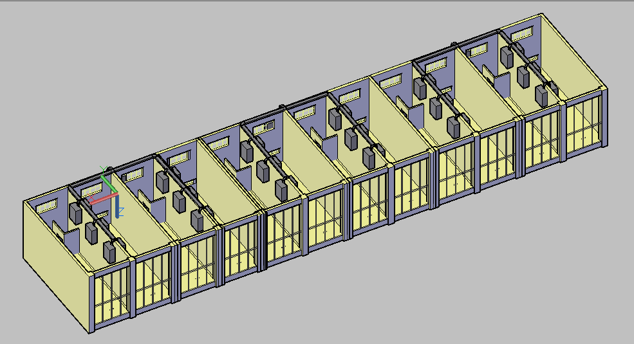

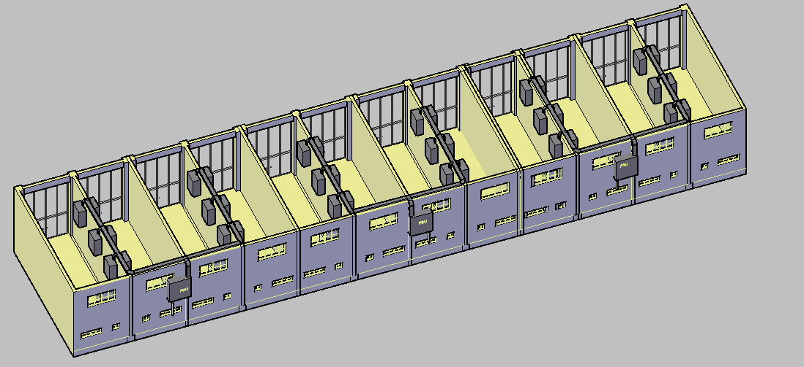

**SECOND FLOOR:**

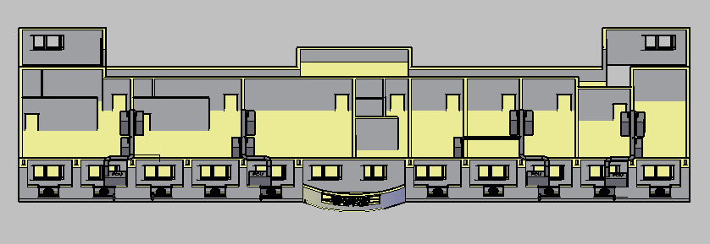

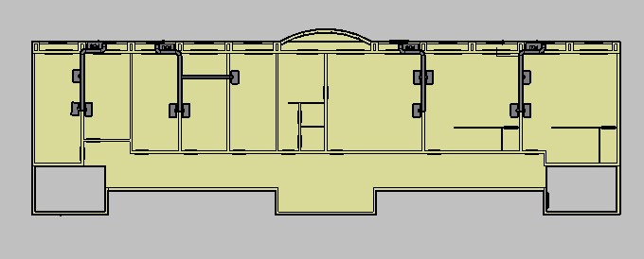

**THIRD FLOOR:**

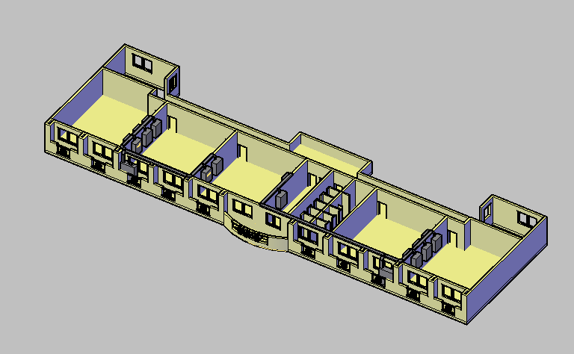

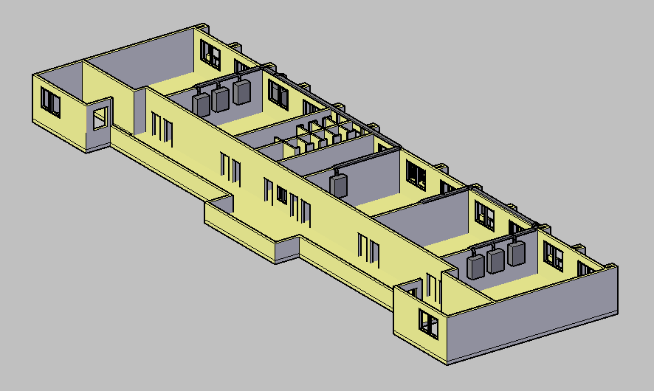

**FOURTH FLOOR:**

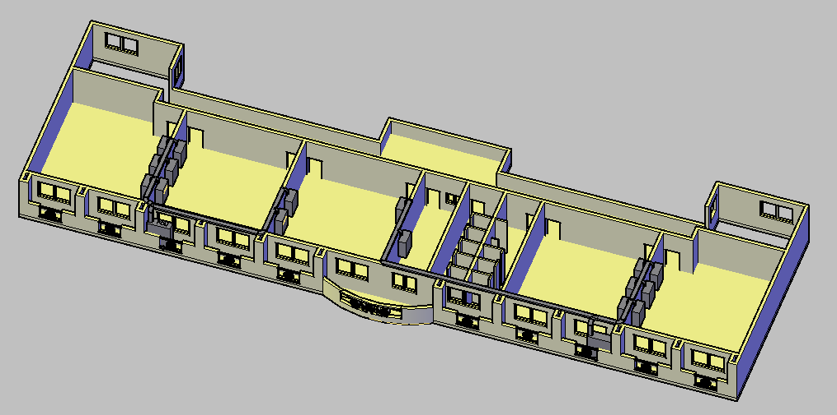



**PENTHOUSE:**

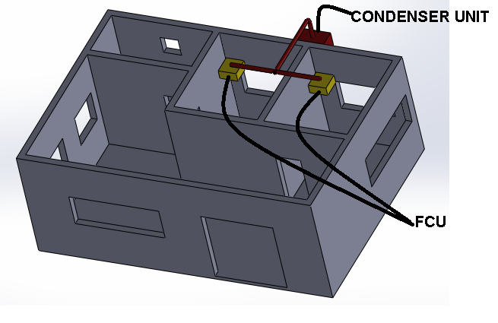

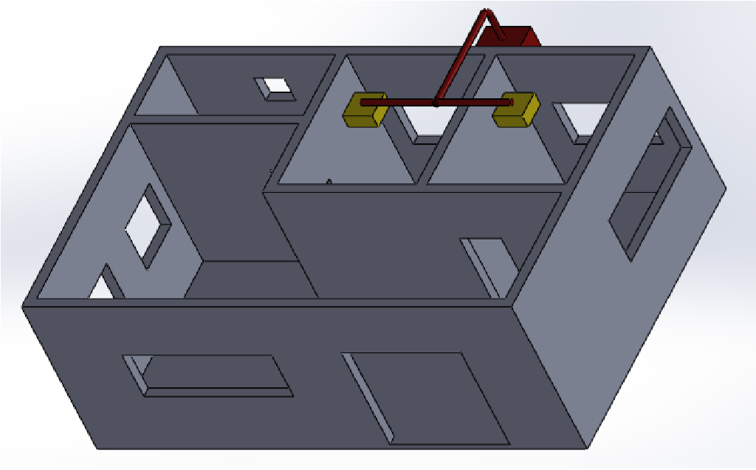

**FLOOR PLAN**

**GROUND FLOOR PLAN**

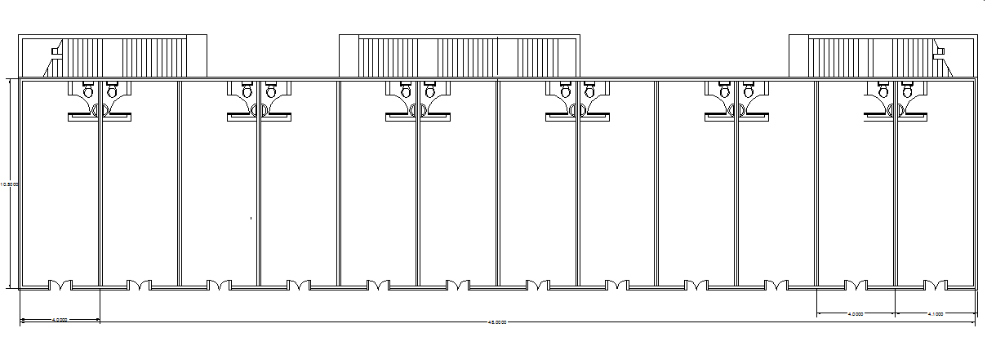

**SECOND FLOOR PLAN**

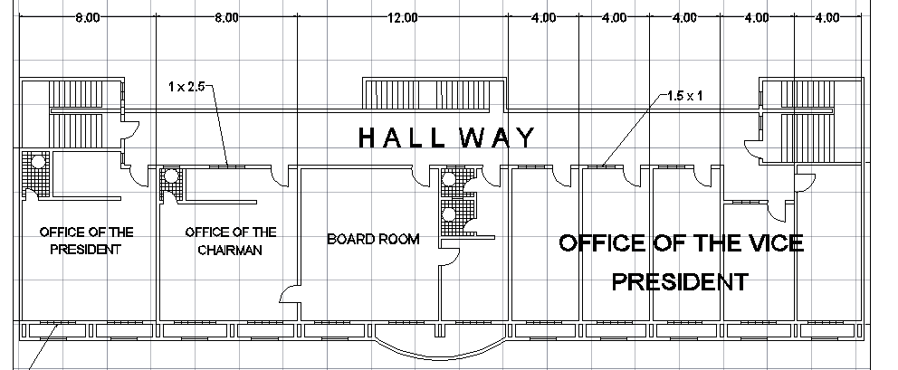

**THIRD AND FOURTH FLOOR PLAN**

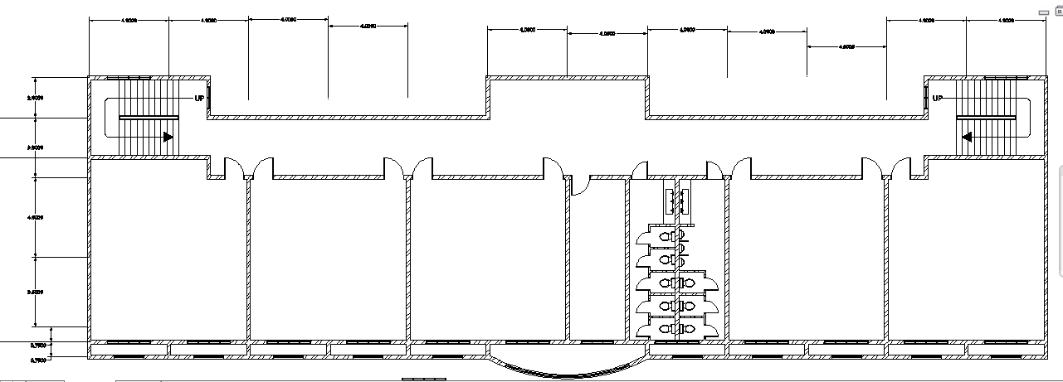

C𝑎𝑎83 3 +101.325 the Volume is calculated from the equation:

**CHAPTER VI**

**DESIGN RECOMMENDATION AND CONCLUSION**

This chapter presents the conclusion and recommendations of the design of multi-split type air conditioning system for four-storey school building located at University of Batangas compound, Hilltop, Batangas City. Multi-split type air conditioning system is selected as the type of A/C unit to be installed in the school building. Also, exhaust fans are installed in each bathroom for ventilation purposes.

After completing the air conditioning design, we the proponents concluded that the knowledge taught by our instructor from his air conditioning manual and actual experiences are essential in finishing our design project. We learned that in designing air conditioning system, many factors should be considered such as the location of the building, altitude, floor area, number of condition space, building’s orientation and many more. The design calculation will vary based on these factors and will lead the researchers to come up with the most suitable air conditioning system for the entire building. However, this air conditioning system may still be change for further improvement.

For future references and system improvements of air conditioning of the said building, appropriate air conditioning unit that must be used the following recommendations:

1. Considering the most economical type of air conditioning system by choosing at the available catalogue.
2. In order to meet the standard human comfort, considered all the factors affecting the overall design such as the different appliances use especially for the commercial spaces at the ground floor.
3. In choosing air conditioned unit to be used in this building, look for those unit having lesser tolerance from the computed heat load of the spaces needed to be conditioned.